

Daylesford Foto Biennale Inc AOo45714L
ABN 70496228247

PO Box 569 Daylesford Vic 3460 Australia
Email info@daylesfordfotobiennale.org
www.daylesfordfotobiennale.org
tel + 61 3 5348 5703

$2000 CHILLOUT 2008 PHOTOGRAPHY PRIZE WINNER

PRESS RELEASE Friday March 7th 2008
for immediate release

Sydney photographer Fiora Sacco wins Chillout Photography Prize

At the launch of the ChillOut 2008 Photography Prize last night at the Woodshed Gallery in Daylesford, Daylesford Foto Biennale Inc. President Julie Millowick announced the awarding of the $2000 prize, as chosen by eminent photographer, TVC director and ChillOut Prize judge Rob Imhoff, to Sydney photographer Fiora Sacco’s beautifully crafted and engaging portrait “Our Time”.

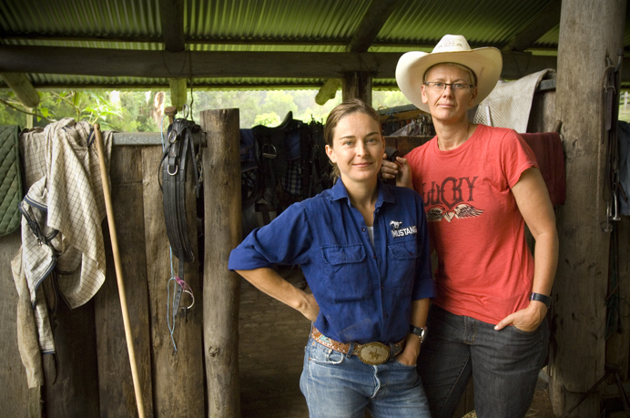
“Our Time” © Fiora Sacco

Advised of her win By Daylesford Foto Biennale Festival Director Jeff Moorfoot via
telephone last night, Fiora said
“I am so thrilled to have won this Prize. I feel a great sense of belonging to the glbt community, and this image reflects that connection.”
Fiora has a long and accomplished career that encompasses newspaper photo journalism, corporate, editorial and high end commercial photography. Her journey has been coloured by politicians, Oscar wining actors, lesbian icons and extraordinary every day people.

As well as announcing the winner of the prize, two high commendations went to
Daylesford photographer Tim Burder for his tongue in cheek “Everyone Loves a Parade” and Coomoora’s Libby O’brien for her surreal portrait “On the way Homo”
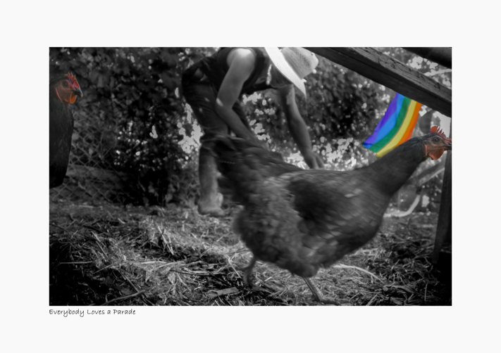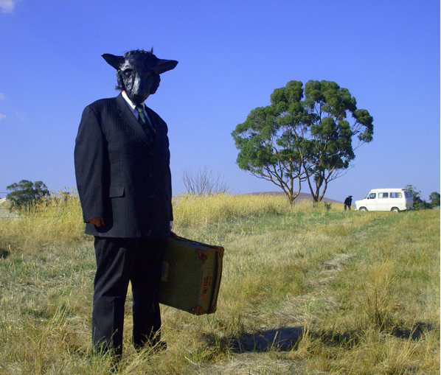
Everyone Loves a Parade© Tim Burder On the way Homo © Libby O’Brien

Entrants were asked to submit photographs based on the theme of the Chillout 2008 Festival ‘Queer as Country Folk’ The prize is instigated and run by the Daylesford Foto Biennale as a profile event in their off year.

The Chillout 2008 Photography Prize exhibition continues daily from 10am to 4pm
at the Woodshed Gallery, 21A Raglan Street Daylesford until Monday March 10th
as part of the 2008 ChillOut Festival

for further info and higher resolution images contact the Daylesford Foto Biennale
office on [03]5348 5703 or <info@daylesfordfotobiennale.org>

